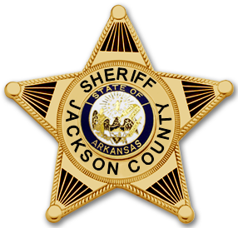 | JACKSON COUNTY SHERIFF’S OFFICE  OFFICIAL PRESS RELEASE

Press Release

Military grave marker theft’s
May 25, 2015: The Jackson County Sheriff’s Office is currently seeking information involving the thefts of bronze military grave markers from local cemeteries. Below is an example of the stolen markers that have been described to us. If anyone has any information involving these thefts, please contact the Jackson County Sheriff’s Office by phone at 870-523-5842 or email us at jacksoncid@yahoo.com. Any and all help is appreciated.

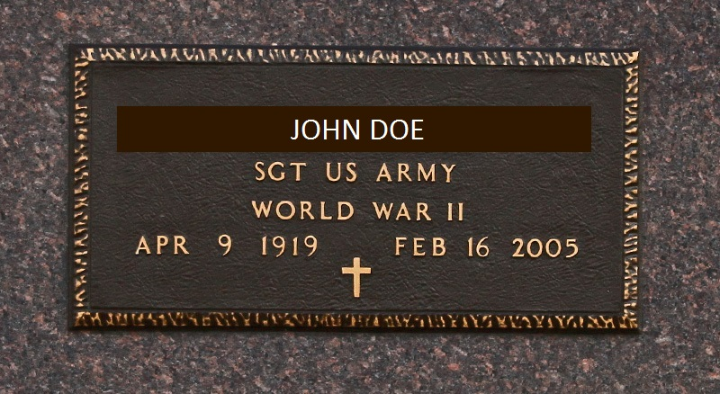

Corporal Justin Collom
Jackson County Sheriff’s Office
Criminal Investigation Division

